Part A — Practice Programs (Hour 1)
Work these in your lab-NN/ folder before the project: do the first one or two in the lab; the
last (For Advanced Learners) is for home.
1. Remote control: an interface Switchable with on()/off() and a default toggle(); Fan and
Light implement it. Loop over a Switchable[] toggling each. Then add a functional
interface that decides, given a device and an hour, whether it may switch on, and supply it
once as an anonymous class and once as a lambda.

import java.util.Scanner;
interface Switchable {
void on();
void off();

default void toggle() {
on();
off();
}
}

class Fan implements Switchable {
public void on() {
System.out.println("Fan is ON");
}

public void off() {
System.out.println("Fan is OFF");
}
}

class Light implements Switchable {
public void on() {
System.out.println("Light is ON");
}

public void off() {
System.out.println("Light is OFF");
}
}

interface SwitchPermission {
boolean canSwitchOn(Switchable device, int hour);
}

public class RemoteControl {
public static void main(String[] args) {
Scanner sc = new Scanner(System.in);

Switchable[] devices = {new Fan(), new Light()};

System.out.println("1. Fan");
System.out.println("2. Light");
System.out.print("Choose device: ");
int choice = sc.nextInt();

if (choice < 1 || choice > 2) {
System.out.println("Invalid choice");
sc.close();
return;
}

Switchable device = devices[choice - 1];

System.out.println("1. ON");
System.out.println("2. OFF");
System.out.println("3. TOGGLE");
System.out.print("Choose operation: ");
int operation = sc.nextInt();

if (operation == 1) {
device.on();
} else if (operation == 2) {
device.off();
} else if (operation == 3) {
device.toggle();
} else {
System.out.println("Invalid operation");
}

System.out.print("Enter hour (0-23): ");
int hour = sc.nextInt();

if (hour < 0 || hour > 23) {
System.out.println("Invalid hour");
sc.close();
return;
}

SwitchPermission p1 = new SwitchPermission() {
public boolean canSwitchOn(Switchable d, int h) {
return h >= 6 && h <= 22;
}
};

SwitchPermission p2 = (d, h) -> h >= 6 && h <= 22;

System.out.println("Anonymous class: "
+ p1.canSwitchOn(device, hour));

System.out.println("Lambda: "
+ p2.canSwitchOn(device, hour));

sc.close();
}
}
OUTPUT:
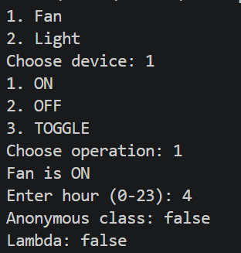
2. Notification senders: a functional interface Notifier with send(String); make email and
SMS senders as lambdas, hold them in an array, and broadcast one message through all.
Add a marker interface Urgent and send twice for senders marked urgent.

import java.util.Scanner;
interface Notifier {
void send(String message);
}
interface Urgent {
}
class UrgentEmail implements Notifier, Urgent {
public void send(String message) {
System.out.println("Email: " + message);
}
}
public class NotificationDemo {
public static void main(String[] args) {
Scanner sc = new Scanner(System.in);

System.out.print("Enter notification message: ");
String message = sc.nextLine();

Notifier email = m -> System.out.println("Email: " + m);
Notifier sms = m -> System.out.println("SMS: " + m);

Notifier[] senders = {email, sms};

System.out.println("\nNormal broadcast:");

for (Notifier sender : senders) {
sender.send(message);
}

Notifier urgent = new UrgentEmail();

System.out.println("\nUrgent broadcast:");

urgent.send(message);

if (urgent instanceof Urgent) {
urgent.send(message);
}

sc.close();
}
}
OUTPUT:
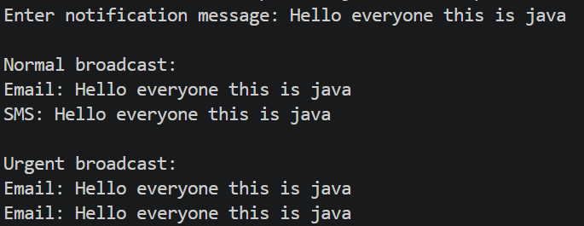

Key Questions / Analysis / Interpretation :
1. What is the difference between an interface and an abstract class?
An interface defines a contract that classes implement. An abstract class can provide shared state, constructors and both abstract and concrete methods.
2. What is a functional interface, and how does a lambda use it?
A functional interface has exactly one abstract method. A lambda expression provides an implementation of that method concisely. In MiniBank, a lambda can implement WithdrawRule.
3. Why is a default method useful in an interface?
A default method provides an implementation inside an interface, allowing implementing classes to use it without having to override it.

